Quality Assurance Document

Table of Contents

Quality Assurance Document 2

About 2

Business Rules 2

Database 3

Application Design and Installation 3

*Application Design* 3

Installation 4

Testing 6

Manual Testing 6

Unit Testing 26

Database GUI 26

Log In Form (with DB verification) 27

Attempts: 30

Final GUI Design 31

32

## Quality Assurance Document

### About

This document is to ensure that the quality of our project is of the best possible standard and this is achieved by following certain rules. If the rules are followed, then this high standard is maintained and there is little room for error as a result throughout production.

### Business Rules

*Team Member Qualities*

The qualities of each team member play an important part in the development of our project to the highest standard possible.

All team members have the same skill level concerning coding and are all highly responsible and have good organisation skills. Therefore, we all possess the same qualities and can take our project to its highest possible level of excellence.

Since we all have the same skill level, we will all play an equal role in the development of our project and divide the project between us all. So, we all have a part in writing the code for it and therefore have a part in research which will be done on the code beforehand.

*Project Development Strategy*

A diagram such as a flowchart will first be created depicting the outline of the project. This will assist in getting the right initial design to start off and build the project on. By starting the project with a flowchart, we minimise room for error such as forgetting components of the project.

Our project will be then split into smaller parts and each team member will be assigned a component and will work on it. To assure that each part will be written to its highest standard, the components will be assigned to each team member according to their strengths in the area of code that is needed to write each part. By breaking the project up into segments, it makes it easier to handle and work on and moreover, to prevent the frequent occurrence of mistakes.

Furthermore, each piece of code written by each team member will be added on GitHub when finished, where it will be reviewed by the other members to check for any errors or if there is anything that could be improved.

Once all the project’s segments are completed, they will then be fused together and modified to form the complete version.

The final version of the project will be then tested thoroughly to see if it meets all the requirements and to see if there are any gaps in its functionality or if anything needs improving.

### Database

We were given the option of choosing any Standard Query Language (SQL), however were encouraged to try SQLite as a starting point of the project. Although at this point the team has had previous experience with MySQL through other modules on our course, after doing some research into SQLite and its functionality we decided to stick with it. This is mainly for its ease of use, small amount of effort to set up, and its relative ease to pick up syntactically due to its similarity to other languages.

SQLite, created by Dr. Richard Hipp, had created it with application use in mind. Unlike other query languages used more typically for big enterprise data depots, requiring extensive setup processes to ensure proper data redundancy, SQLite runs within the same application address and requires no configuration to setup. Using SQLite keeps the program fully encapsulated without the need of communication with an external process, as seen when using MySQL for example. With all this in mind however, we decided we would continue with the pearson learning and decide after having a deeper understanding of python and its workings.

After having more experience with Python, it was a continued feeling of preference towards SQLite and its simplicity. Additionally, after more research into the language it was discovered its commonly used amongst conglomerates for most embedded systems, including companies such as Apple, Google and most android based companies. We did also learn however of SQLites main disadvantage, it is very poor for allowing multiple users to access the data at once, especially when trying to consider certain access requirements for each of user. With this in mind, SQLite still is the more suited database library for us to use, having only one user accessing the data at any given time with no change in access requirements, we see no reason for overcomplicating the program with something more extensive.

### Application Design and Installation

### *Application Design*

Our project application launches with a log in page where the user is prompted to log in using their username and password.

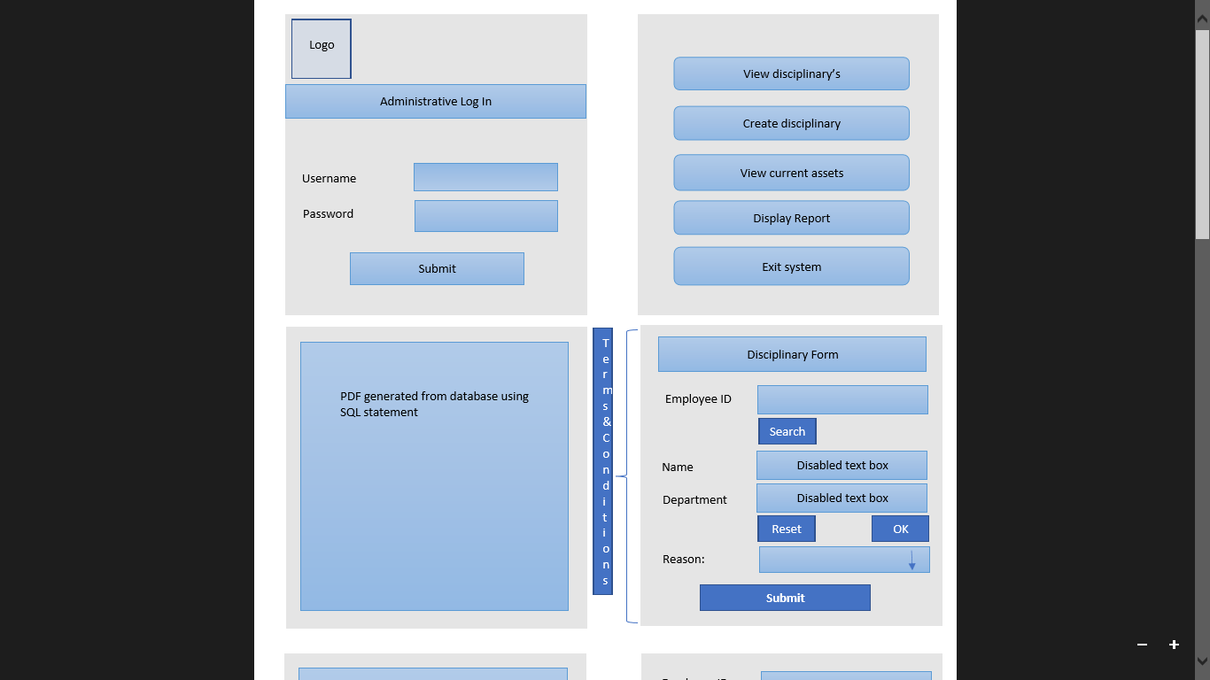

If the log in was successful, then the user will be directed to a new page.

The page that they are directed to has the following screen components:

* A search feature to search for an employee or an asset
* An add / create feature that allows the user to add a new asset or employee
* A feature that allows the user to view all available employee details and/ or assets
* A delete feature that allows the user to delete an employee or asset if need be
* A save feature to save any changes to the database
* A booking feature that enables the user to book an asset
* An exit button for the user to terminate the program

All above features are based on the application mockup and are not confirmed features which might therefore change until the completion of the program.

### Installation

Once the application is installed, they will be given instructions on how to connect it to their database for it to work. No further instructions will be required as the application is designed in such a way to be simple to use and for its features to be self-explanatory.

The user will however need to agree to certain terms before proceeding after logging in for the first time which are all stated in the LSEPI document. These terms include but are not limited to data protection and the integrity of the user.

## Testing

### Manual Testing

Test Plan 1

|  |  |  |  |
| --- | --- | --- | --- |
| Date: | 25/02/21 | Tested By: | Jack Davies |
| System: | Login Page | Environment: | Python |
| Objective: | Check if the system will login without entering any details or accepting the terms and conditions box. | Test ID: | 1 |
| Version: | 1 | Test Type: | Absent |
| Status: | In Process |  |  |
|  | | | |
| Type of Tests | Before | After | Result |
| * Invalid * Boundary * Valid * Wrong * Absent | The type of test that will occur will be an absent test. This test will include no input to see if the appropriate error will occur. | The type of test in the above screenshot is an absent test. As you can see, no data has been entered into the textboxes and the terms and conditions box has not been accepted. | As there was no data being entered and tick boxes have not been ticked, an error message has occurred to tell the user to check their input. This test was successful because we do not want our program to allow the user to login without the correct login details and without accepting the terms and conditions. We also do not want our program to crash either if an error occurs. |

Test Plan 2

|  |  |  |  |
| --- | --- | --- | --- |
| Date: | 25/02/21 | Tested By: | Jack Davies |
| System: | Login Page | Environment: | Python |
| Objective: | Try to login without entering the correct login details | Test ID: | 2 |
| Version: | 1 | Test Type: | Invalid |
| Status: | In Process |  |  |
|  | | | |
| Type of Tests | Before | After | Result |
| * Invalid * Boundary * Valid * Wrong * Absent | The type of test that will occur will be an invalid test. This test will include inputting incorrect details to see if the system will login in or if the appropriate error will occur. | The type of test in the above screenshot is an invalid test. As you can see, the wrong details have been entered into the textboxes. However, the terms and conditions have been accepted which means the only error that should occur would be about incorrect login details. | An incorrect username and password have been entered, which created an error. This test was successful because the user should not be allowed to login with incorrect details. The correct error message appeared too, and the program did not crash. |

Test Plan 3

|  |  |  |  |
| --- | --- | --- | --- |
| Date: | 25/02/21 | Tested By: | Jack Davies |
| System: | Login Page | Environment: | Python |
| Objective: | Try to login without accepting the terms and conditions. | Test ID: | 3 |
| Version: | 1 | Test Type: | Absent |
| Status: | In Process |  |  |
|  | | | |
| Type of Tests | Before | After | Result |
| * Invalid * Boundary * Valid * Wrong * Absent | The type of test that will occur will be an absent test. This test will try to login without accepting the terms and conditions. | The type of test in the above screenshot is an absent test. As you can see, the terms and conditions box has not been ticked which means the user should be able to login without accepting it. | This test was successful because the user did not accept the conditions and an error message appeared informing the user to accept the conditions if they wish to continue. |

Test Plan 4

|  |  |  |  |
| --- | --- | --- | --- |
| Date: | 25/02/21 | Tested By: | Jack Davies |
| System: | Login Page | Environment: | Python |
| Objective: | Login by using correct usernames and passwords and by clicking the accept button for the terms and conditions. | Test ID: | 4 |
| Version: | 1 | Test Type: | Valid |
| Status: | In Process |  |  |
|  | | | |
| Type of Tests | Before | After | Result |
| * Invalid * Boundary * Valid * Wrong * Absent | The type of test that will occur will be a valid test. This test will try to login by using correct usernames and passwords and by clicking the accept button for the terms and conditions. | The type of test in the above screenshot is a valid test. As you can see, the terms and conditions box has been accepted and the data has been inputted for the username and password. | This test was successful because the user entered correct login details and they also accepted the conditions. No error message appeared, on a message to say welcome to the user. |

|  |  |  |  |
| --- | --- | --- | --- |
| Date: | 25/02/21 | Tested By: | Jack Davies |
| System: | Login Page | Environment: | Python |
| Objective: | Login by inputting incorrect data in the usernames and passwords textboxes. But also accepting the button for the terms and conditions. | Test ID: | 5 |
| Version: | 1 | Test Type: | Invalid |
| Status: | In Process |  |  |
|  | | | |
| Type of Tests | Before | After | Result |
| * Invalid * Boundary * Valid * Wrong * Absent | The type of test that will occur will be an Invalid test. This test will try to login by incorrect usernames and passwords and by clicking the accept button for the terms and conditions. | The type of test in the above screenshot is an invalid test. As you can see, the terms and conditions box has been accepted and the data has been inputted for the username and password. However, they are incorrect details. | This test was successful because an error message has appeared informing the user that the only error that has occurred is an input error. Meaning that either the username or password is incorrect. |

Test Plan 6

|  |  |  |  |
| --- | --- | --- | --- |
| Date: | 25/02/21 | Tested By: | Jack Davies |
| System: | Login Page | Environment: | Python |
| Objective: | No SQL injection security was implemented in our code. This caused a vulnerability which could cause a lot of damage if not corrected. | Test ID: | 6 |
| Version: | 1 | Test Type: | Boundary |
| Status: | In Process |  |  |
|  | | | |
| Type of Tests | Before | After | Result |
| * Invalid * Boundary * Valid * Wrong * Absent | The type of test that will occur will be a boundary test. No SQL injection was implemented. | The type of test in the above screenshot is a boundary test. The line that the error occurs is SELECT * FROM Password WHERE ID = ? AND Password = ? % id, passw) | This test was unsuccessful. If the user enters a legitimate search value, for example, 1478, in the above statement then all fine. But if they try something untoward, for example, 1478'; DROP TABLE Password; then the results are fatal.  The statement passes ID and Password from the client directly to the database, without performing any sort of check or validation. This sort of code is perfect for inviting SQL injection.  Test plan 7 will show how we will correct this vulnerability. |

Test Plan 7

|  |  |  |  |
| --- | --- | --- | --- |
| Date: | 25/02/21 | Tested By: | Jack Davies |
| System: | Login Page | Environment: | Python |
| Objective: | No SQL injection security was implemented in our code. This caused a vulnerability which could cause a lot of damage if not corrected. | Test ID: | 7 |
| Version: | 2 | Test Type: | Boundary |
| Status: | In Process |  |  |
|  | | | |
| Type of Tests | Before | After | Result |
| * Invalid * Boundary * Valid * Wrong * Absent | The type of test that will occur will be a boundary test. No SQL injection was implemented. | The type of test in the above screenshot is a boundary test. The line that the error occurs was SELECT * FROM Password WHERE ID = ? AND Password = ? % id, passw)  but now we have changed it to  SELECT * FROM Password WHERE ID = ? AND Password = ?, ( id, passw)) | This test was successful. In this statement, id and password are passed as named parameters. Now, the database will use the specified type and value of the parameters when executing the query, offering protection from Python SQL injection. |

Test Plan 8

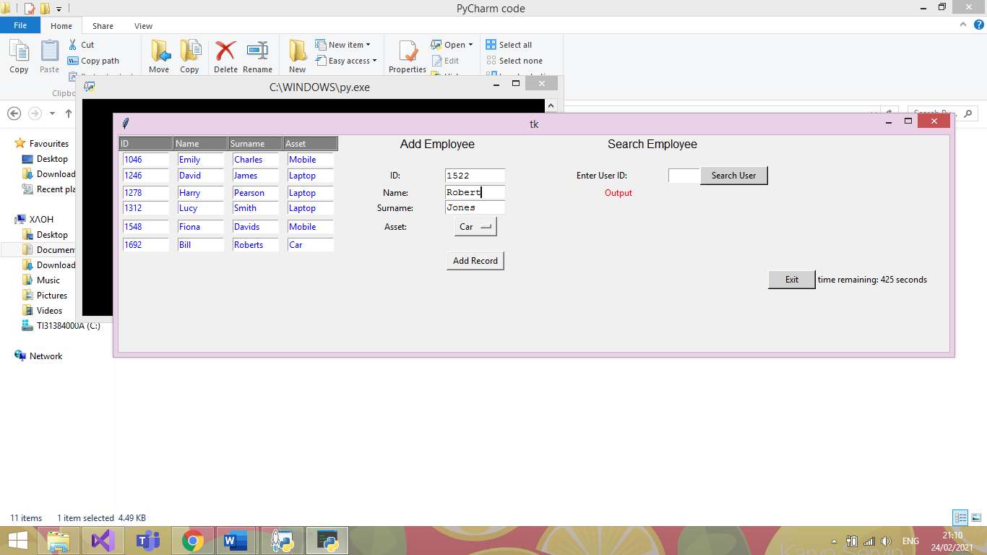

|  |  |  |  |
| --- | --- | --- | --- |
| Date: | 25/02/21 | Tested By: | Jenni Whewell |
| System: | Administrator Main Page | Environment: | Python |
| Objective: | Checking to see if details of ID, Name, Surname and Asset can be added to the database | Test ID: | 8 |
| Version: | 1 | Test Type: | Valid |
| Status: | In Process |  |  |
|  | | | |
| Type of Tests | Before | After | Result |
| * Invalid * Boundary * Valid * Wrong * Absent | The test above is to check whether user details can be added to the database with the correct values to the text boxes. | The information in the test above is to check if a user can add valid information. | From the image below, it is clearly indicated that the test was successful where the entry is seen with user ID 1522 in the table adjacent. |

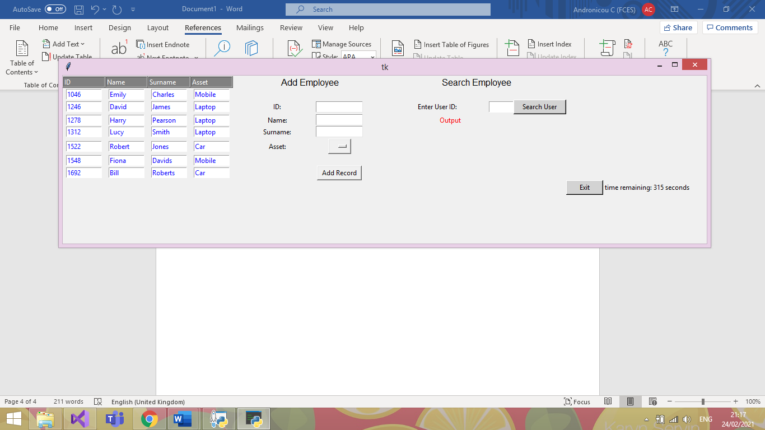

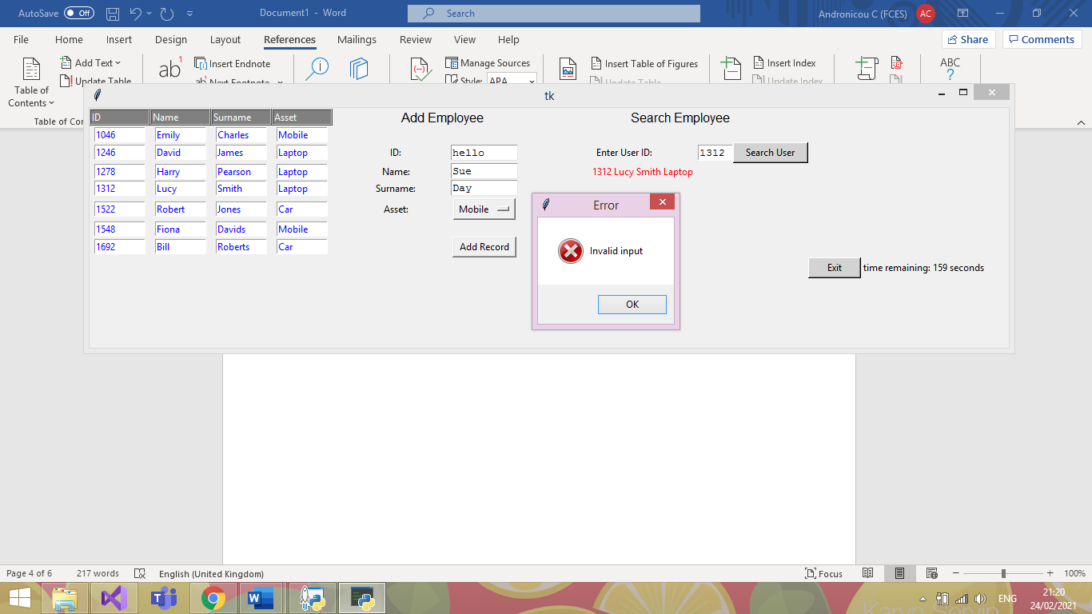Test Plan 9

|  |  |  |  |
| --- | --- | --- | --- |
| Date: | 25/02/21 | Tested By: | Jenni Whewell |
| System: | Administrator Main Page | Environment: | Python |
| Objective: | Entering a string in the user ID text box. | Test ID: | 9 |
| Version: | 1 | Test Type: | Invalid |
| Status: | In Process |  |  |
|  | | | |
| Type of Tests | Before | After | Result |
| * Invalid * Boundary * Valid * Wrong * Absent | An invalid test is executed to see if it throws an error. This type of test is known as an invalid test.  For the test we are entering the word “hello” | The type of test in the above screenshot is an invalid test. As you can see, the first name and surname have all be entered correctly with just the user ID being inputted wrong. | This test was successful because an error message has appeared informing the user that the only error that has occurred is an input error. Meaning that the user ID has been entered incorrectly. |

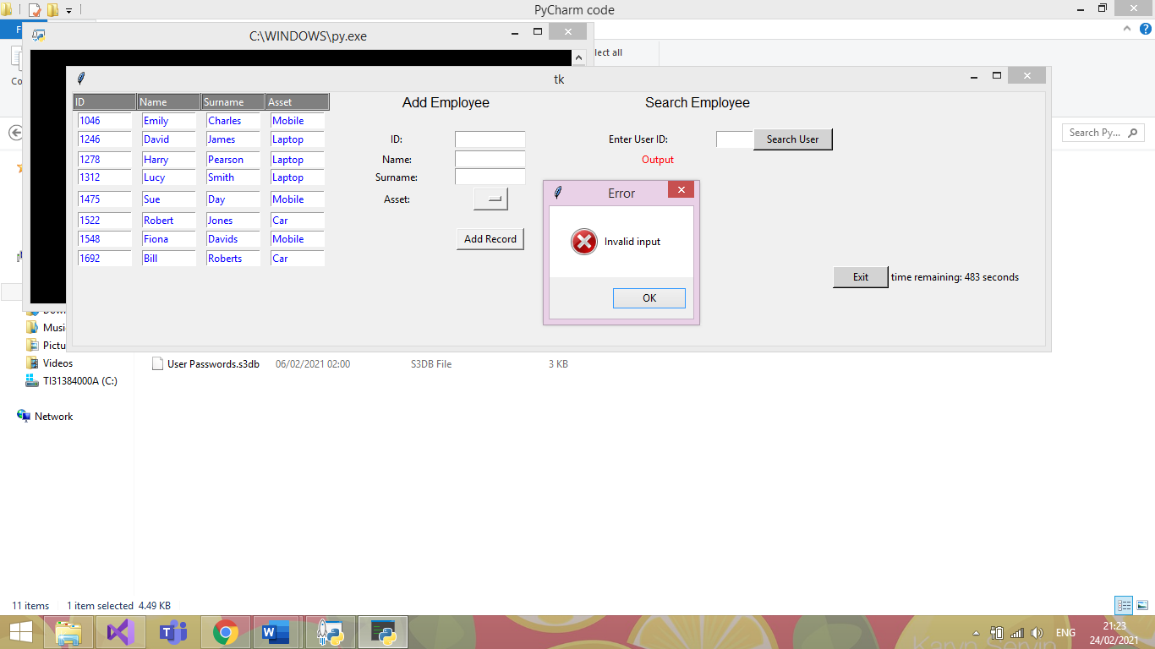Test Plan 10

|  |  |  |  |
| --- | --- | --- | --- |
| Date: | 25/02/21 | Tested By: | Jenni Whewell |
| System: | Administrator Main Page | Environment: | Python |
| Objective: | The user clicks add without entering any details. | Test ID: | 10 |
| Version: | 1 | Test Type: | Absent |
| Status: | In Process |  |  |
|  | | | |
| Type of Tests | Before | After | Result |
| * Invalid * Boundary * Valid * Wrong * Absent | An absent test is executed in the screenshot above. The purpose of the test is to check what happens if the text boxes are left empty. | An absent test is good to check so that there are no empty entries in the database. This means that the primary keys of the database will not except a NULL value. | This test was successful because an error message has appeared informing the user that the only error that has occurred is an input error. Meaning that information needs to be added to the text boxes for it to be a successful entry. |

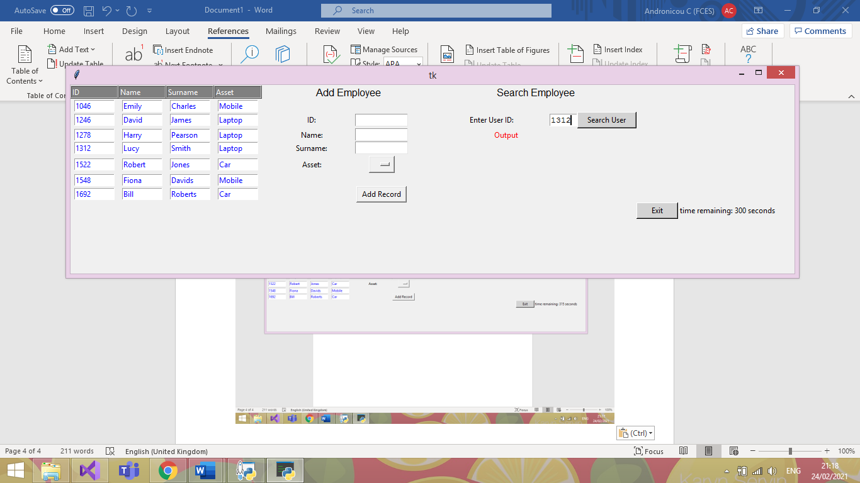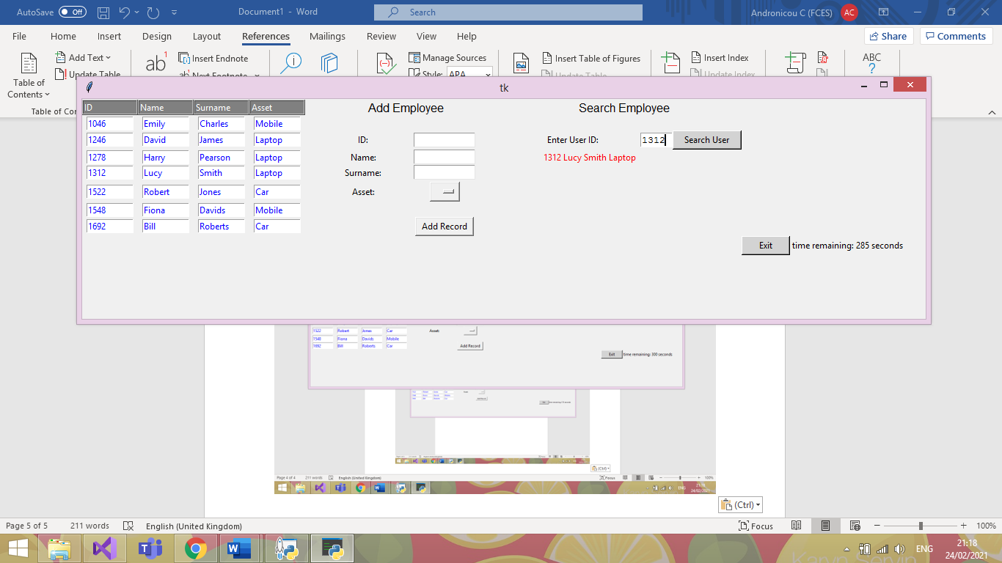Test Plan 11

|  |  |  |  |
| --- | --- | --- | --- |
| Date: | 25/02/21 | Tested By: | Jenni Whewell |
| System: | Administrator Main Page | Environment: | Python |
| Objective: | Searching for a user by their ID number. | Test ID: | 11 |
| Version: | 1 | Test Type: | Valid |
| Status: | In Process |  |  |
|  | | | |
| Type of Tests | Before | After | Result |
| * Invalid * Boundary * Valid * Wrong * Absent | In the first screenshot, the user ID 1312 is entered for the purpose of the search test. The purpose of a valid test is to check if the program is outputting the correct result when asking the system for details. | The details that should be outputted in the result of the test should include the first name, surname, and the asset that the employee has taken.  With the user ID 1312, the name should be Lucy smith and the asset should be a laptop. | This test was successful because all the correct details have appeared. This means that the form can take valid inputs from the system and it will output the correct details. |

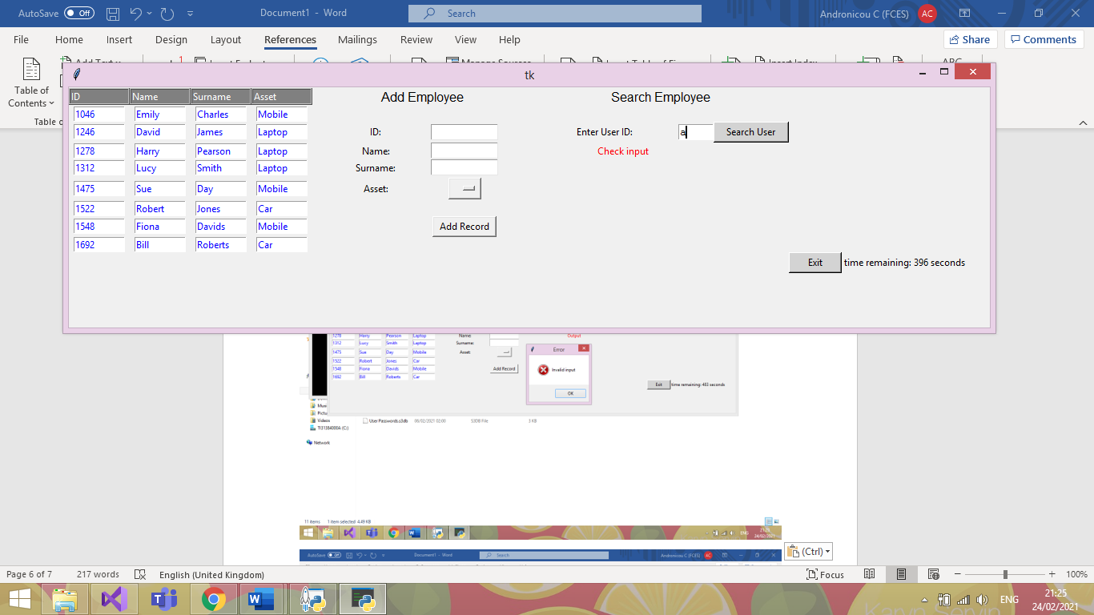Test Plan 12

|  |  |  |  |
| --- | --- | --- | --- |
| Date: | 25/02/21 | Tested By: | Jenni Whewell |
| System: | Login Page | Environment: | Python |
| Objective: | The user enters invalid input to search | Test ID: | 12 |
| Version: | 1 | Test Type: | Invalid |
| Status: | In Process |  |  |
|  | | | |
| Type of Tests | Before | After | Result |
| * Invalid * Boundary * Valid * Wrong * Absent | The type of test that will occur will be an Invalid test. This test will try to search for a user by a string which is not the correct data type. | An invalid test is good to check so that there are no unwanted entries in the database. This means that the test will not return the first entry in the database if the input is wrong. | This test was successful because an error message can be seen in red to indicate to check the input. |

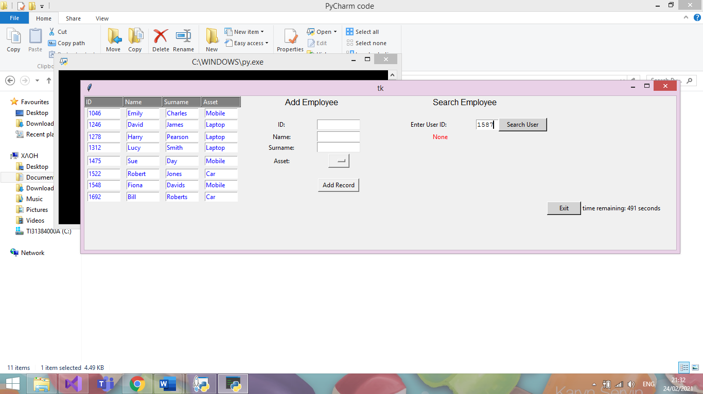Test Plan 13

|  |  |  |  |
| --- | --- | --- | --- |
| Date: | 25/02/21 | Tested By: | Jenni Whewell |
| System: | Administrator Main Page | Environment: | Python |
| Objective: | Entering a user’s ID that is not present. | Test ID: | 13 |
| Version: | 1 | Test Type: | Wrong |
| Status: | In Process |  |  |
|  | | | |
| Type of Tests | Before | After | Result |
| * Invalid * Boundary * Valid * Wrong * Absent | The type of test that will occur will be a wrong test. This test will try to search for a user using the correct data type, however, the user does not exist. | A wrong test is good to check so that a user is not getting accused of taking out an asset if that is not the case. This is vital to ensure that correct data is being stored in the database. | This test was successful because an error message can be seen in red to indicate that no such user exists in the database. Which in this case is true. |

Test Plan 14

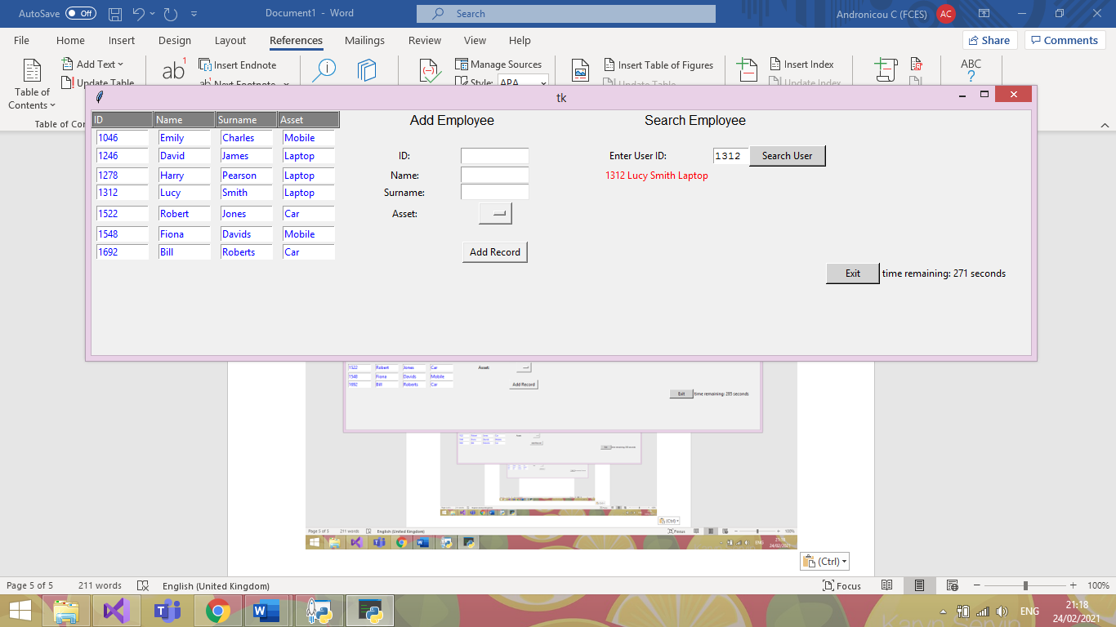



|  |  |  |  |
| --- | --- | --- | --- |
| Date: | 25/02/21 | Tested By: | Jenni Whewell |
| System: | Login Page | Environment: | Python |
| Objective: | Checking that the exit buttons timer works for security purposes. | Test ID: | 14 |
| Version: | 1 | Test Type: | Valid |
| Status: | In Process |  |  |
|  | | | |
| Type of Tests | Before | After | Result |
| * Invalid * Boundary * Valid * Wrong * Absent | This valid test is to check whether the timer for the exit button works successful, counting down so that the form closes within the time limit unless something is inputted to the GUI. | In the first screenshot, the timer is seen starting when the form is initially opened.  This test is important as this means that if the user does not interact with the GUI then it will shut down.  This allows for the system to be secure so if the user leaves to computer unattended then unauthorised users cannot access it. | As you can seen from the second screenshot, the test was successful with the time remaining decreasing from the first screenshot. An important aspect of authorisation and authentication. |

Test Plan 15

|  |  |  |
| --- | --- | --- |
| Before Deleting | When Deleting | After Deleting |
|  |  |  |

|  |  |  |  |
| --- | --- | --- | --- |
| Date: | 25/02/21 | Tested By: | Jenni Whewell |
| System: | Administrator Main Page | Environment: | Python |
| Objective: | Checking that the delete function works as expected | Test ID: | 15 |
| Version: | 1 | Test Type: | Valid |
| Status: | In Process |  |  |
|  | | | |
| Type of Tests | Before | After | Result |
| * Invalid * Boundary * Valid * Wrong * Absent | This test is important as it utilizes the ability to delete a user if they no longer have an asset in the company or end up leaving the company. | The first screenshot indicates all the entries in the database. The second screenshot is what happens when a user is selected. For the purpose of the, test user ID 1278. The outcome should see this user being deleted from the database and the entries below and above should all stay the same. | The test was partially successful with the entry that was required to be deleted was. However, one thing that does happen is that it duplicates another value in the database.  For fixing this error, we could set the primary key which is the user ID to not except duplicate values and this will stop the error. This can be fixed in the next phase. |

Test Plan 16

|  |
| --- |
| Before Asset Update |
|  |
| After Asset Update |
|  |

|  |  |  |  |
| --- | --- | --- | --- |
| Date: | 25/02/21 | Tested By: | Jenni Whewell |
| System: | Administrator Main Page | Environment: | Python |
| Objective: | Checking that the update function works as expected | Test ID: | 15 |
| Version: | 1 | Test Type: | Valid |
| Status: | In Process |  |  |
|  | | | |
| Type of Tests | Before | After | Result |
| * Invalid * Boundary * Valid * Wrong * Absent | This test is important as it utilizes the ability to update a user’s asset if needed. | For the purpose of the test, user ID 1278 is used. The outcome should see the specified user asset is changed to the asset selected by the user. | The test was successful with the entry that was required to be updated was. |

### Unit Testing

The main goal with the automatic testing is to ensure that any quick refactoring’s done to the project, will not damage the core functionality. Due to our project not only using a GUI, but also its use of SQLite to add a database, it makes it very difficult to conduct traditional Unit testing appropriately.

Additionally, I have attempted to incorporate DocTesting in hopes to have more success with the GUI/Database but still to no avail.

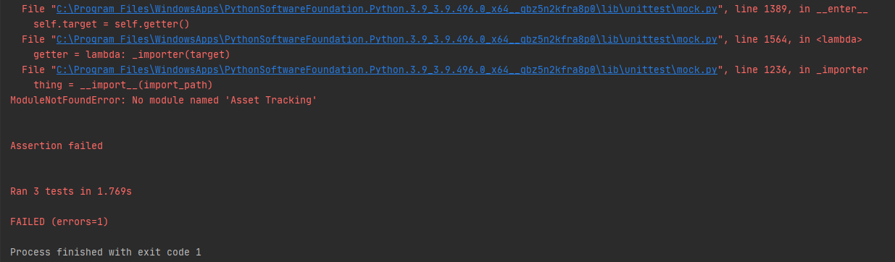

Due to the 2 external dependencies, as aforementioned, it increases the difficulty of employing these forms of testing quite significantly as you can see in the above *PrintScreen*. This as far as my research has shown, there is no real way for the testing suite to ‘see’ the changes made to the GUI.

We can however test that our input validation works correctly, and that the program wont crash when given values it cannot handle. Essentially it is only the core logic that may be tested through these means, other areas of our program must be tested manually to validate their current working state.

### Database GUI

**Functions being tested:**

* Add_Data()
* Search(ID)

**Test Purpose:**

* Check correct exceptions thrown where appropriate.
* 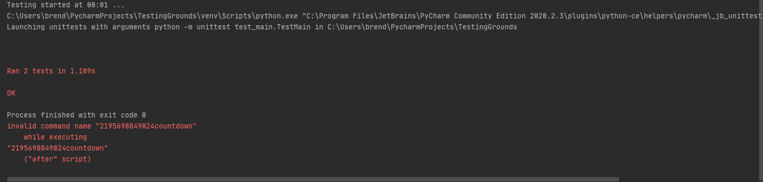Logic works as expected.

### Log In Form (with DB verification)

**Functions being tested:**

* My_details()

**Test Purpose:**

* Check correct exceptions thrown where appropriate.

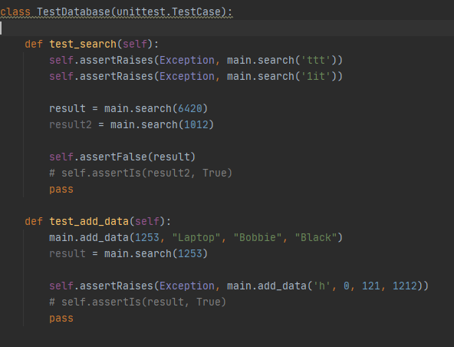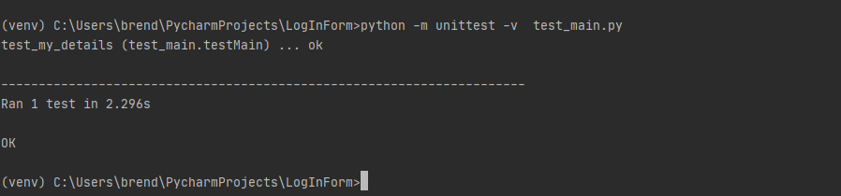

References/Helpful Links (Why GUI test automation bad)

[https://www.theregister.com/2007/10/22/gui_unit_testing/#:~:text=Of%20course%20GUI%20applications%20can,test%20GUIs%22%20because%20it's%20difficult.](https://www.theregister.com/2007/10/22/gui_unit_testing/%23:~:text=Of%20course%20GUI%20applications%20can,test%20GUIs%22%20because%20it's%20difficult.)

Arguments that GUIs should be tested with Units in mind, however not the UI itself necessarily but rather the implemented logic of the program. Essentially confirms the methods we have followed, i.e., test base logic, throwing exceptions so on, rather than the GUIs response to them.

<https://softwareengineering.stackexchange.com/questions/207274/should-i-bother-to-write-unit-test-for-ui-ux-components>

A forum exclaiming the same thing, Unit testing has its place more for actual logic testing whereas testing the GUI and how it reacts to the code is more for **‘functional/integration’** testing.

<https://agilewarrior.wordpress.com/2015/04/18/classical-vs-mockist-testing/>

This is where I found the information regarding the ‘Mock’ class and how it can be used for emulating objects in code that you don’t necessarily want to run, a good way to explain it is if you were say hooking up to a website, rather than actually connecting to the site during every test case you run, it’ll instead connect to a ‘mock’ version of the website thus emulating the experience of connecting to a site.

Useful when working with something difficult to test or is legacy code/cannot be refactored.

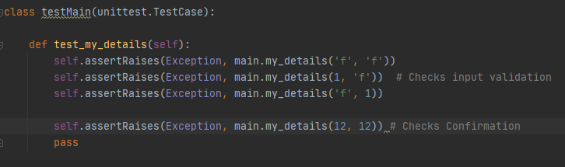I did try to implement this also, I tried to emulate a GUI framework to work with but had no real research to help with that one. I then tried to emulate the DB just to test the add_Data() functionality, but I then had issues with SQL queries trying to run on the ‘fake’ DB.

A way we could implement the unit testing appropriately is by using an MVC pattern (cool how our modules cross over though!). Due to it being split into, you could say, ‘units’ it makes it far simpler to test. Again, only the core functionality of a given function can be tested, GUI testing still proves to be best done by human eye (as far as my research shows so far anyway, it can be done in other frameworks quite easily but so far nothing for tkinter within reason)

<https://www.semicolonworld.com/question/59599/how-do-i-run-unittest-on-a-tkinter-app>

So, this link is the closest to a solution I have found, and it entails essentially setting the GUI to execute in another thread while the testing continues in the main thread. Of course, my knowledge of threading is stretched as it is, but in this sense, I was completely lost on what to do. However, it does seem like a viable option for the future.

### Attempts:

This was an attempt to create a fake database just to test the add_data function but with a separate database not to edit our original. This did not work, at all.

class TestDatabase(unittest.TestCase):  
  
 def setUp(self):  
 *"""  
 Setup a temporary database  
 """* conn = sqlite3.connect("testDatabase.db")  
 cursor = conn.cursor()  
 # create a table  
 cursor.execute("""CREATE TABLE test  
 (id text, name text, surname text,  
 options text)  
 """)  
 # insert some data  
 cursor.execute("INSERT INTO test VALUES "  
 "('1012', 'Dave', 'Parkhouse',"  
 "'Laptop'")  
 # save data to database  
 conn.commit()  
 # insert multiple records using the more secure "?" method  
 testVals = [('1654', 'Andy', 'Hunter',  
 'Laptop'),  
 ('9865', 'Red', 'Davies',  
 'Laptop'),  
 ('6545', 'Krutch',  
 'Jones', 'Tablet'),  
 ('7845', 'Lee', 'Evans',  
 'Laptop')]  
 cursor.executemany("INSERT INTO test VALUES (?,?,?,?)",  
 testVals)  
 conn.commit()  
 def tearDown(self):  
os.remove("mydatabase.db")

This was then an attempt at using ‘mock’ to emulate a database, again this did not work, at all. The SQL queries were not able to execute on my ‘test’ DB sadly so would just get constant exceptions.

# Final GUI Design

Log In page

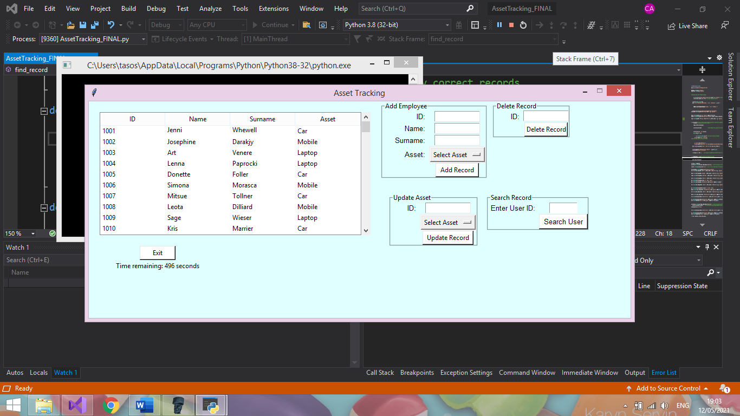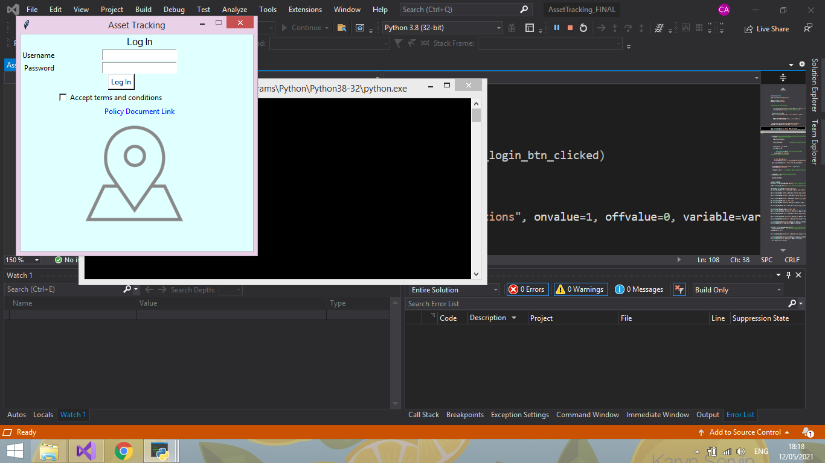

Administrator Main page

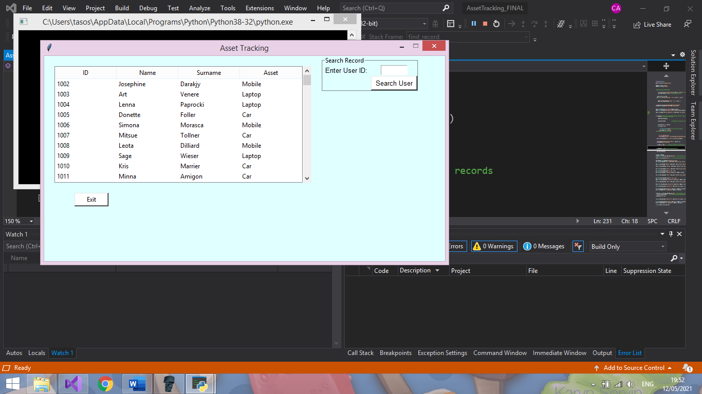

# 

Employee Main page

Administrator Main page